Wheeled Device and Adaptive Cycle Users’ Mobility Experiences with Cycling Infrastructure: Summary and Recommendations

People who use wheeled mobility devices (wheelchairs, scooters, powerchairs) have difficulty getting around in cities. Sidewalks can be challenging in terms of their maintenance, missing curb cuts, sidewalk clutter and pedestrians. Some of these device users will alternatively use cycle lane infrastructure,, but this is not officially sanctioned with current legislation. The purpose of this study was to learn more about how users with disabilities navigate pathways with different devices, and how to improve cycling infrastructure for a variety of users. The study findings were based on 31 semi-structured interviews and 23 interviews conducted with participants after completing a cycle lane excursion with the research team. The interviews explored the transportation experiences of people with disabilities using a variety of different wheeled mobility devices. Our participants provided valuable recommendations based on their daily experiences using urban pathways.
People who use wheeled mobility devices should have equitable access to urban pathways that can provide safe and convenient means of travel. We invite you to consider the following recommendations in your approaches to policy and community action in Metro Vancouver.

Infrastructure Recommendations

Signage and Visibility
Problem | Recommendation
Poor signage at construction sites:  There is absent or minimal signage indicating a closed sidewalk. If present, they are only at the site and do not inform mobility device users in advance.  Mobility device users must retrace their steps and search for a new route to their destination, often with inaccessible infrastructure. | Signage at construction sites that indicates where the sidewalk is closed.  Signage should be visible in advance to allow mobility device users to make an alternative decision. Signage should also indicate an accessible alternate route.
Low driver attention to intersection corners when turning:  Drivers do not pay attention to intersection corners when turning right; they do not see mobility device users travelling in the cycle lanes and sidewalks and cut them off when turning right. | Paint curbs yellow at intersections to focus the attention of drivers towards the cycle lanes and sidewalks.  Painted curb bulbs have also been suggested and utilized in some municipality infrastructure planning to potentially increase visibility and improve safety.,
Poor visibility at night:  There is little street lighting, which causes mobility device users to be at risk as they are not easily seen at night. | More street lighting at night for visibility of mobility-device users.
Objects at intersection obstructing drivers’ line of sight:  Objects such as trashcans, hedges, poles, and mailboxes at intersections can easily obstruct a driver’s view of device-users.  This causes mobility device users to be at substantial risk of being unseen and injured. | Reduce the number of objects at intersections that can obstruct drivers’ view of device-users in cycle lanes and sidewalks, especially when turning right:  E.g. trashcans, hedges, poles, mailboxes, etc.

Cycle Lane Infrastructure
High speed of vehicles:  In streets where it is easy to speed, vehicles are not slowing down. This causes many pedestrians, cyclists, and device-users to be at risk, affecting their safety. | Increase vehicle traffic calming measures such as: Painted lanes and curbs, stop signs, speed signs, etc.  In addition to curb bulbs, HUB Cycling had previously suggested a “bend-out” design for Town Centre Streets in Burnaby.
Inaccessible cyclist traffic calming poles/gates:  In cycle lanes or shared pathways, there are traffic calming poles or gates that often require a dismount before passing through.  People with disabilities find it challenging to dismount their bicycle or device to navigate these features. However, they still agree that traffic calming measures should be implemented for bicycles. | Remove traffic calming poles and replace with other cyclist speed reducers and traffic calmers.  Suggestion for speed reducer: Near Science World in Vancouver, there is a pedestrian crosswalk that cuts through a bike path. The bike path is surrounded by curb-like blocks fashioned from old dragon boats (see Appendix for photo). The dragon boats narrow as cyclists near the crosswalk organizing them into single file. Footrests are available to encourage cyclists to stop and wait for pedestrians to cross.
Lack of safety next to cars:  Cycle lanes that are directly next to moving cars are often only separated by paint.  Mobility-device users are unsafe when there is no physical barrier between moving cars and themselves. Parked cars are also a risk, as there is a concern of being “doored.”  Among all the concerns, this was the one most frequently emphasized by the participants. | More Separated Cycle Lanes. Recommendations for barriers in order of preference:  - Cement flower planters (flowers increase enjoyment of commute)  - Raised cement lanes  - Jersey barriers  - Poles  - Parking between cycle lanes and moving cars (mixed reviews for this option due to concern of getting “doored”)  - Green painted lanes are not considered separated but are preferred over shared roadways.
Uneven lanes:  Bumps in the lanes can be difficult to navigate.  Device-users can be injured by these bumps. Uneven ground can also exacerbate pain levels or cause spasms. | Increase maintenance to ensure that lanes are flat and smooth with no cracks. Consider new materials.
Congregated cyclists:  In areas where groups of cyclists block the entire cycle lane.  This makes it difficult for people using mobility devices to pass as they cannot go around on grass or pop down the curb. | Create a staging area for groups of cyclists on cycle lanes or urban pathways.
Narrow cycle lanes:  Narrow cycle lanes make it difficult for cyclists and mobility device users to pass other users. | Wider cycle lanes that allow other users to pass mobility device users easily. Wider lanes also allow mobility device users to maneuver safely within the lanes.
Lack of continuity in cycle lanes:  Cycle lanes can end abruptly without notice.  It is challenging for device-users to find an alternate accessible route to major destinations. Re-routing is difficult as they must navigate inaccessible side streets or sidewalks to connect to major routes. | Longer, more continuous separated cycle lanes that connect major cycling routes.
Cross-slope:  Cross-slopes make travel difficult for manual wheelchair-users. They must push harder on one side. | A crown in the middle of urban pathways rather than a slope would eliminate excessive one-sided pushing.
Different speeds for different users:  People travel in cycle lanes at different speeds. This is an increasing concern with the introduction of electronic devices (e-bikes, e-scooters, electric standing scooters) with unregulated speeds.  This is a safety concern for all cycle lane users. | Passing lanes: Introduce multiple cycle lanes for different purposes.  - Having a slow and fast lane  - Having a lane for wheeled mobility devices (especially in areas of steep incline)  - Increase signage to indicate how the lanes should be used (akin to HOV signage)  - Encourage more sustainable modes of transportation

Sidewalk Infrastructure
Missing curb cuts:  - Missing curb cuts cause unexpected re-routing or extra planning.,  - When sidewalk landings are a part of the curb cut, it is difficult to maneuver. | Accelerate curb cut implementation.  - Have more curb cuts, ideally at every corner  - Allow space for landing area for curb cuts to allow wheeled devices to turn easily.
Tree root bumps:  Cracked and uneven surfaces from overgrown tree roots can be difficult to navigate.  Mobility device-users can suffer injuries, must re-route, or be forced to use roads. | Trim tree roots more often or use more sustainable sidewalk materials.

Access to Features
Crosswalk buttons that cannot be reached:  Crosswalk buttons can be placed too high, in places where device-users cannot access, and hard to push for people with disabilities. | Accessible crosswalk buttons:  - Lower and more reachable buttons  - Avoid placing buttons over grass medians (a mobility device may not be able to access)  - Motion activated buttons (for both sidewalk and cycle lane buttons)  - Audible cues in addition to visual
Separate buttons for sidewalk and cycle lanes:  At some intersections with only crosswalk buttons, those using the cycle lanes must come onto the sidewalk to push it and then re-enter the cycle lane posing different challenges for different device users. | More traffic lights and buttons for cycle lanes in addition to sidewalk crossing buttons.

Policy and Education Recommendations
Problem | Recommendation

Policy
Many mobility device users encounter barriers when using sidewalk infrastructure and find using cycle lanes smoother and safer. | Allow mobility device users to use cycle lanes by amending the policy.
Recent rise in speed in cycle lanes:  The introduction of electric devices (e-bikes, e-scooters) have increased the speed of users in cycle lanes.  This is a safety concern for all users. | Legislation for Speed Limits:  - Speed limits for dedicated cycle lanes  - Enforcement for violations of the speed limits and those dodging in and out of lanes
Inattentiveness to surroundings:  Headphones can interrupt one’s attention to the environment. This can pose dangers to those who use headphones on cycle lanes, as well as others around them. | Policy regarding the dangers of wearing headphones while on cycle lanes.
Street conditions & debris:  Snow, fallen leaves, or debris are barriers for wheeled mobility-device users to maneuver. | Increased Street Cleaning:  Improved removal of snow and fallen leaves from cycle lanes.
Lack of knowledge or action from the city:  When policymakers are unaware of existing infrastructure concerns, there is a lack of action to fix them. E.g., cracks in sidewalks, insufficient alternate routes from construction, too much slope on driveway etc.  - There have been accounts of participants reporting their concerns and expressing frustrations over the lack of follow-up. | Reporting/Notification System:  More awareness and accessibility of notification systems for mobility-device users to report concerns with infrastructure.  Let’s Talk-Delta was recommended as a useful model.
Sudden stops at stop signs:  Sudden stops or stop signs for cycle lane users can increase the risk of being rear-ended by vehicles or other users. | Idaho stops:  Allowing rolling stops for cycle lane users at stop signs. This prevents the loss of momentum and protects users from getting rear-ended by vehicles or other lane users.
Cost for leisure, health, and mobility:  Devices such as tricycles can be expensive, and cost can be a barrier to exercise and recreation for people with disabilities. | Coverage, subsidization, or insurance for tricycles or handcycles for people with disabilities. Cycling offers an important source of exercise, and recreation with subsequent positive health impacts.

Education
Stigma towards mobility-device users:  Society can have negative or unfair judgements for mobility-device users who use cycle lanes, which can impact their means of transport. | More public awareness and education on how cycle lanes may be used as an accessible mode of transport for people with mobility devices.  - Education modules or advertisements like what ICBC does for cars.
Lack of etiquette on shared pathways:  Different shared pathway users such as cyclists, e-device users, and mobility-device users may have contradicting practices of etiquette. | Education about shared pathways and the basic etiquette of use, which will involve interactions with other device-users.
Conforming to biking culture:  Certain bike culture, such as dismounting in certain situations, may not be possible for all cycle or scooter-users.  Individuals who experience chronic pain when walking may use cycles or scooters to get around. Not all disabilities are visible, and it may be difficult for them to conform with bike culture. | General public awareness of how different (and everyday) devices can be used as a mobility device.
Lack of driver education after licensing:  While road safety rules and policies continue to change, driver education ceases after one obtains a license.  Careless or high-risk driving can endanger any user of roads, sidewalks, cycle lanes, and pathways. | Continued driver education of road rules, etiquette, and how to interact with cycle lane users would ensure that drivers are up to date on the most recent policies and safety etiquette.
Dogs:  Dogs tend to bark or charge at novel objects, such as wheelchairs.  Wheeled-mobility device users are lower to the ground, and it can be frightening, alarming, unsafe or unpleasant for them if this occurs. | Dog-Owner Education:  - Education on leashing dogs  - Education to dog-owners about dogs feeling threatened and attacking people with disabilities.

Discussion
Overall, the users that we interviewed expressed an interest in increasing the number of separated cycle lanes available and making them accessible to people who use mobility devices. One reason for this preference was related to feelings of unease next to cars, creating stressful journeys over risk of injury concerns. They recommended more inclusive signage that conveys mobility device users' rights to access and potential design solutions to increase safety for those utilizing cycle lane infrastructure and drivers. Cycling infrastructure was not only a means of travel but it also promoted a sense of social belonging used for recreation, health, and socialization. While some users stated they could select the device most appropriate to the route and reasons for their journey, the costs of these devices remain a steep barrier for some users who would like to have them available. Finding ways to help subsidize these costs was another recommendation that could improve social inclusion. In addition to the signage, policy, and maintenance recommendations offered, suggestions for education and awareness campaigns were also emphasized as areas requiring focus from policymakers to address social and physical accessibility barriers to cycling infrastructure for mobility device users.
Appendix
Funding
This study was funded and supported by a SSHRC Partnership grant titled towards barrier free Communities: A partnership for improving Mobility, Access, and Participation (MAP) among people with disabilities.
Partner Organizations
 |  |  | 

Mobility Devices used by Participants: manual wheelchairs, manual chairs with add-ons (freewheel, power front end, ski poles), power wheelchairs, or hand cycles
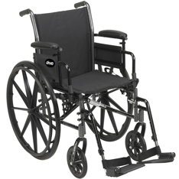 | 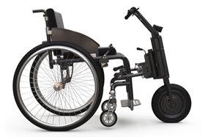 | 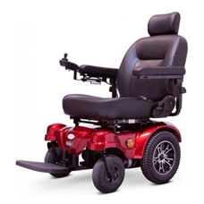 | 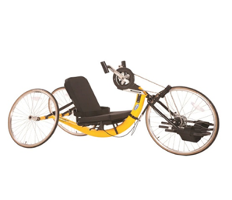
Traffic Calming Measures
Gates
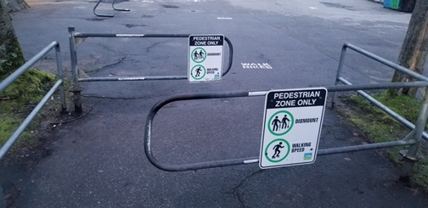 | 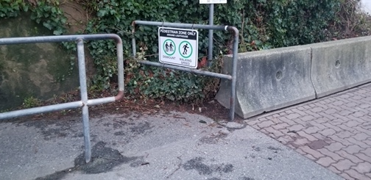 | 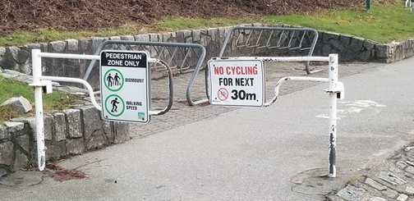
Bollards
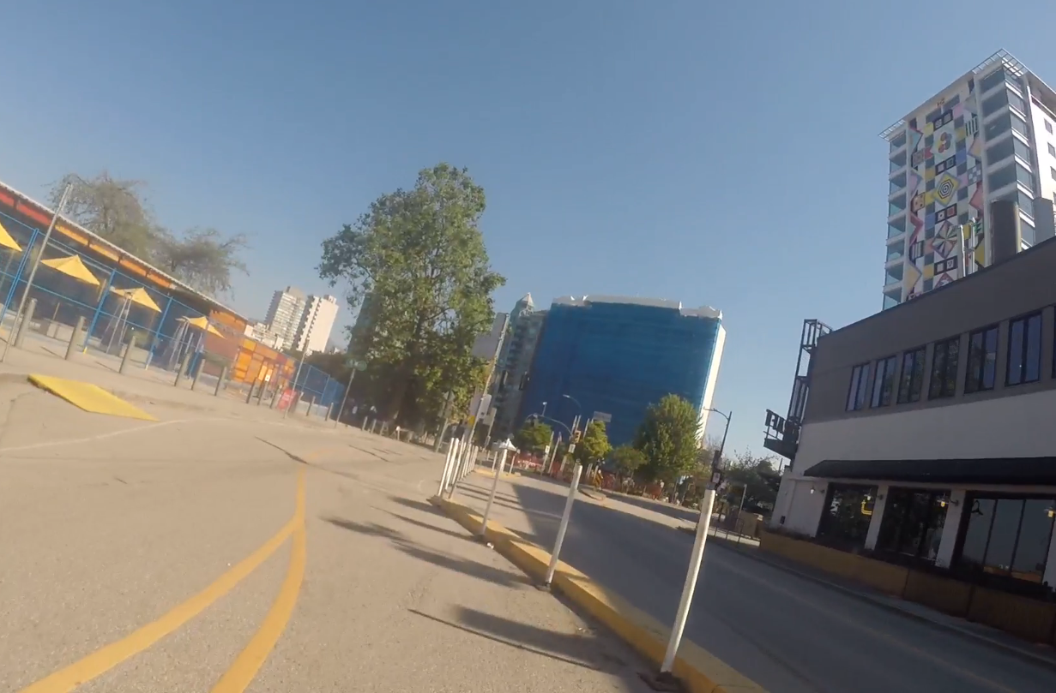 | 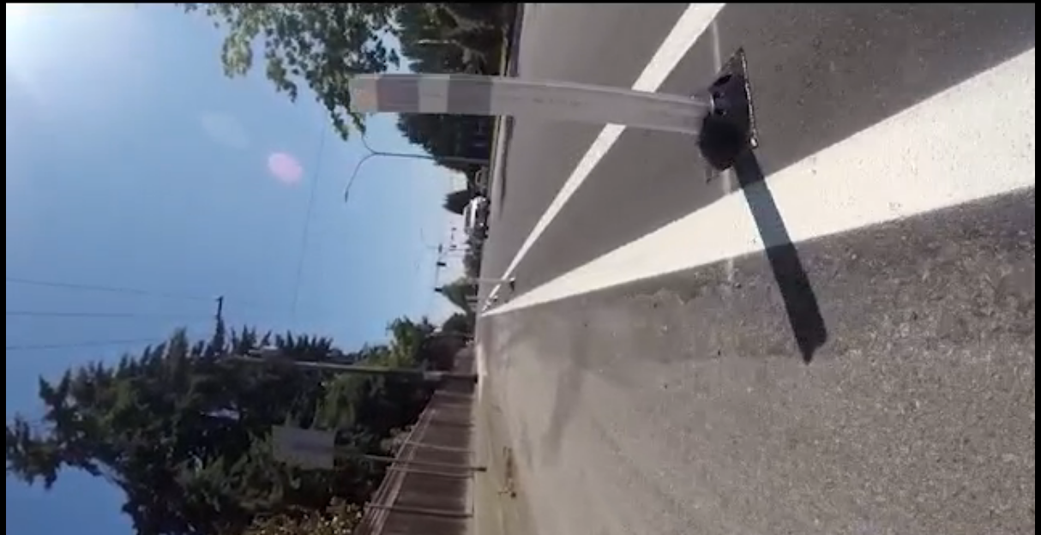 | 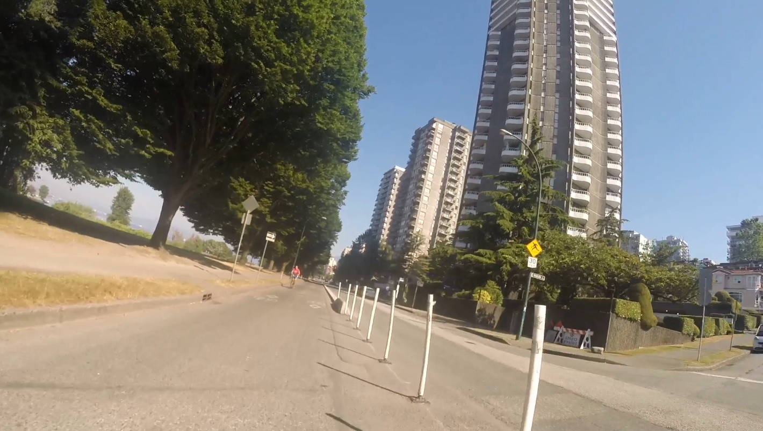

Speed reducer in front of Science World in Vancouver, BC
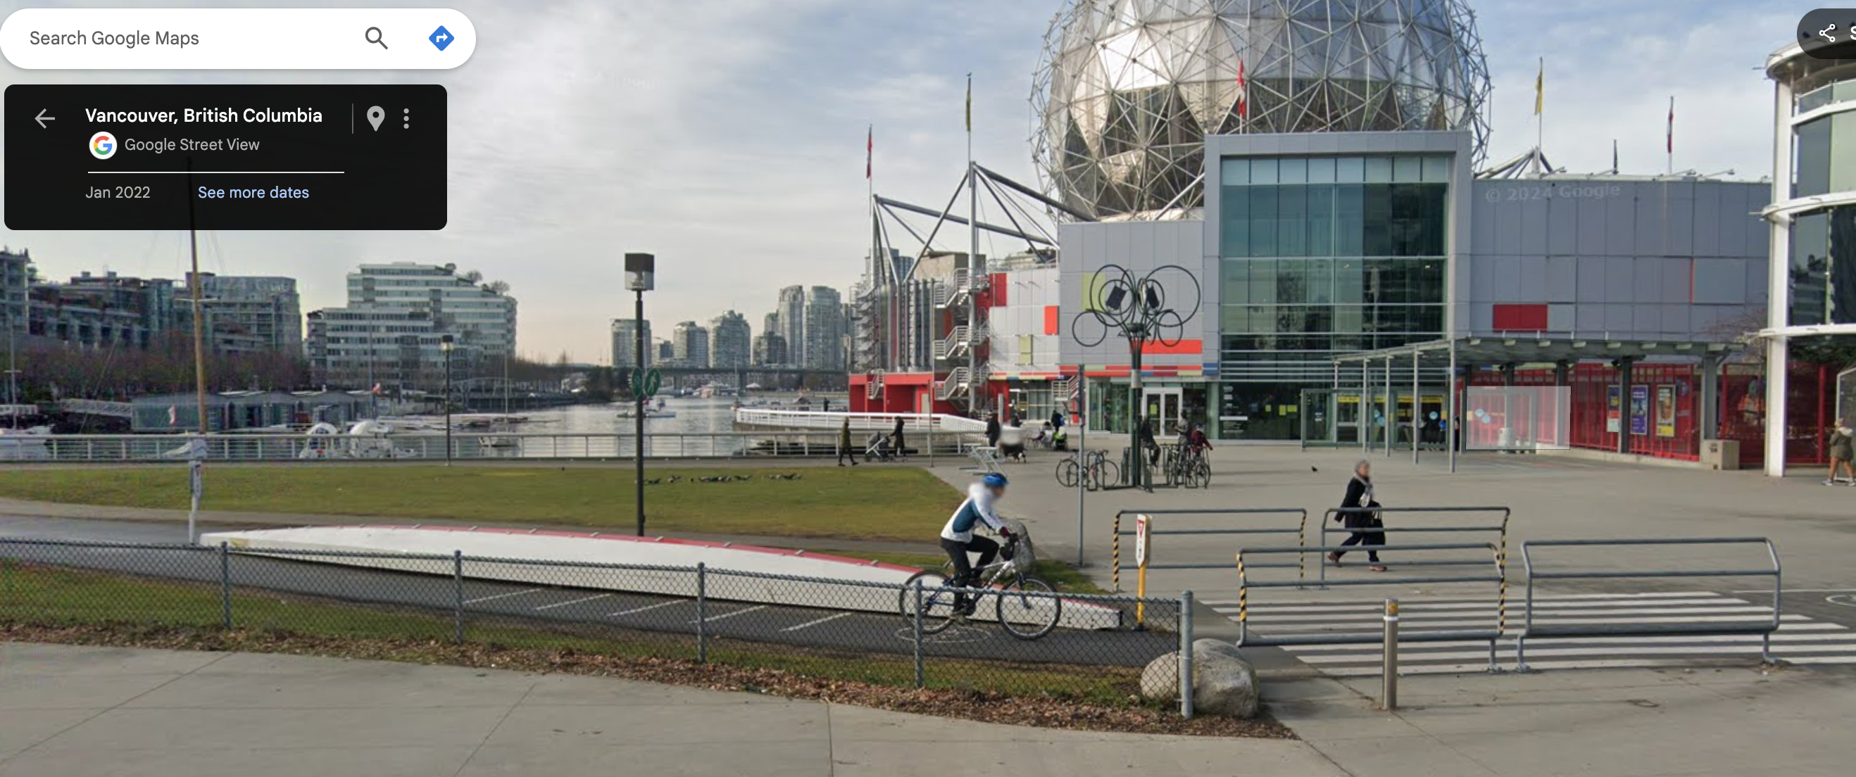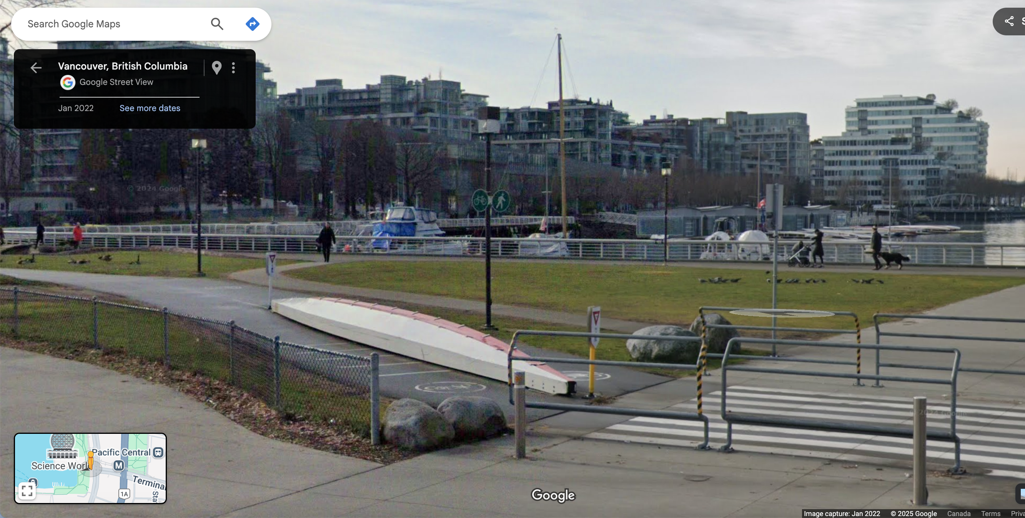
Note. Dragon boat with footrests is used as a speed reducer for cyclists to slow down prior to the pedestrian crosswalk. Photos are from Google Maps.
Google (January 2022). [Google Maps street view of Science World]. Retrieved January 21, 2025, from https://maps.app.goo.gl/pFGgJDejF6dM2Biw8
Signage at construction sites
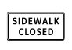 | 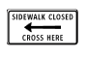 | 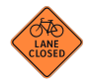 | 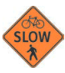
Note. Construction signs are from the Graphic Sign Index Section 5.0 Construction Signs. British Columbia Provincial Sign Program. March, 2024. https://www2.gov.bc.ca/assets/gov/driving-and-transportation/transportation-infrastructure/engineering-standards-and-guidelines/traffic-engineering-and-safety/traffic-engineering/traffic-signs-and-pavement-markings/standard-traffic-signs/standard-traffic-signs/construction_signs.pdf
References
City of Seattle. (2017). The Right-of-Way Improvements Manual. https://streetsillustrated.seattle.gov/design-standards/intersections/pedcrossing/

Followup: Painted ‘curb bulbs’ on Admiral Way at 59th SW, 61st SW. (2017, December 8). West Seattle Blog. https://westseattleblog.com/2017/12/followup-painted-curb-bulbs-on-admiral-way-at-59th-sw-61st-sw/

Zanotto, M., & Griffin, C. (2019). RE: Protected Intersections for Town Centre Streets. https://pub-burnaby.escribemeetings.com/filestream.ashx?DocumentId=43947

Paz, T., Andersen, J., Bolliger, B., Cade, B., Corriveau, L., Franke, T., Millar, M., Peters, G., Wells, B., & Slakov, L. (2017). Active Transportation Policy Council: Vol. Minutes. https://vancouver.ca/docs/council/atpc20171108min.pdf.

Province of British Columbia. (2019). British Columbia Active Transportation Design Guide. https://www2.gov.bc.ca/assets/gov/driving-and-transportation/funding-engagement-permits/grants-funding/cycling-infrastructure-funding/active-transportation-guide-low-res/2019-06-14_bcatdg_section_c_rfs.pdf

Ralph, A. (2020). Contract Award for Construction Services for the Curb Ramp Program: 2020 Feb 12. https://council.vancouver.ca/20200212/documents/pspc3.pdf.

Resources
The following links address design recommendations for cross-slope, curb ramps, visibility, etc.:
https://nacto.org/docs/usdg/accessible_sidewalks_and_street_crossings_boodlal.pdf
https://adatile.com/all-you-need-to-know-about-ada-curb-ramp-requirements/
https://accessible.canada.ca/centre-of-expertise/built-environment#s2.3

These links provide infrastructure standard drawings, including reference to cross-slopes near cycle lanes:
https://vancouver.ca/files/cov/green-infrastructure-standard-drawings.pdf
https://www2.gov.bc.ca/assets/gov/driving-and-transportation/funding-engagement-permits/grants-funding/cycling-infrastructure-funding/active-transportation-guide-low-res/2019-06-14_bcatdg_section_c_rfs.pdf

Cycle lane infrastructure refers to separated cycle lanes, sidewalks, shared paths, greenways, and roads.
For cycle lane or bike lane terminology, we use separated to refer to both protected and dedicated cycle lanes.
Mobility devices used by users included manual wheelchairs, manual chairs with add-ons (freewheel, power front end, ski poles), power wheelchairs, or hand cycles.
The recommendations are listed in order from most actionable to least actionable per sub-section.
Participant mentioned seeing this done in North Vancouver.
City of Seattle. (2017). The Right-of-Way Improvements Manual. https://streetsillustrated.seattle.gov/design-standards/intersections/pedcrossing/.
Followup: Painted ‘curb bulbs’ on Admiral Way at 59th SW, 61st SW. (2017, December 8). West Seattle Blog. https://westseattleblog.com/2017/12/followup-painted-curb-bulbs-on-admiral-way-at-59th-sw-61st-sw/.
One user mentioned feeling more visible on a green cycle lane downtown “...I’m basically riding on a lime green carpet...”
Zanotto, M., & Griffin, C. (2019). RE: Protected Intersections for Town Centre Streets. https://pub-burnaby.escribemeetings.com/filestream.ashx?DocumentId=43947.
Concerns related to being “doored” did not come from users but the experience and expertise of team members and their previous work with similar users.
Areas of high socialization (e.g. Stanley Park) or with organized cycling groups.
According to the Province of British Columbia. (2019). British Columbia Active Transportation Design Guide. https://www2.gov.bc.ca/assets/gov/driving-and-transportation/funding-engagement-permits/grants-funding/cycling-infrastructure-funding/active-transportation-guide-low-res/2019-06-14_bcatdg_section_c_rfs.pdf., a cross-slope of 1.0 to 2.0% is desired for pedestrian facilities, with 0.6% being the minimum allowed.
Paz, et al., 2017 Active Transportation Policy Council: Vol. Minutes. https://vancouver.ca/docs/council/atpc20171108min.pdf. The Active Transportation Policy Council estimated that it would take the City of Vancouver 20 to 200 years depending on the number of new annual installations of 40 or the council’s recommended 400. Paz, T., Andersen, J., Bolliger, B., Cade, B., Corriveau, L., Franke, T., Millar, M., Peters, G., Wells, B., & Slakov, L. (2017).
Ralph, A. (2020). Contract Award for Construction Services for the Curb Ramp Program: 2020 Feb 12. https://council.vancouver.ca/20200212/documents/pspc3.pdf.Two businesses were contracted in 2020 to install 240 curb cuts at 3,800 locations missing them. A rate that would take 16 years to complete all missing sections.
Participant note: ramps are useful for everyone (mobility devices, older adults, strollers, grocery carts, etc.)

